1. Which are the top three variables in your model which contribute most towards the probability of a lead getting converted?

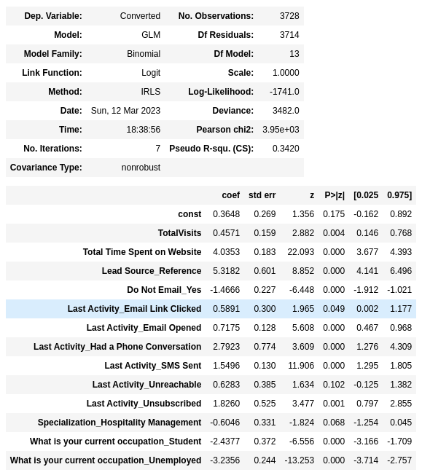Based on the coefficient values from above scree shot, the following are the top three variables that contribute most towards the probability of a lead getting converted :

* Reference(Lead Source)
* Total time spent on website
* Had a phone conversation(Lead Activity)

1. What are the top 3 categorical/dummy variables in the model which should be focused the most on in order to increase the probability of lead conversion?

Based on the coefficient values from the screen shot in the question above, the following are the top three categorical/dummy variables that should be focused in order to increase the probability of lead conversion

* Reference(Lead Source)
* Had a phone conversation(Lead Activity)
* Unsubscribed(Lead Activity)

1. X Education has a period of 2 months every year during which they hire some interns. The sales team, in particular, has around 10 interns allotted to them. So during this phase, they wish to make the lead conversion more aggressive. So they want almost all of the potential leads (i.e. the customers who have been predicted as 1 by the model) to be converted and hence, want to make phone calls to as much of such people as possible. Suggest a good strategy they should employ at this stage.

The below image has the final prediction which calculated based on a optimal cut off value of 0.4. In order to make the sales aggressive, the company may contact all the leads which have a conversion probability (value = 1) under a cut off 0.4 (column 0.4 highlighted in yellow).

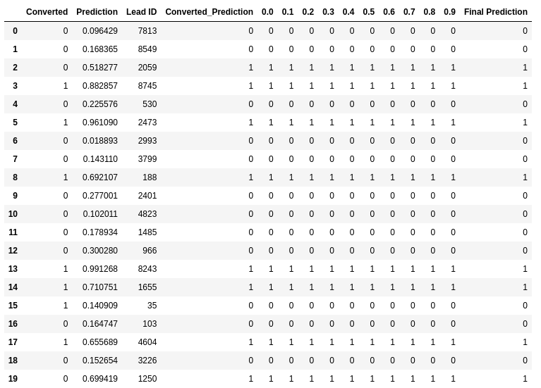

1. Similarly, at times, the company reaches its target for a quarter before the deadline. During this time, the company wants the sales team to focus on some new work as well. So during this time, the company’s aim is to not make phone calls unless it’s extremely necessary, i.e. they want to minimize the rate of useless phone calls. Suggest a strategy they should employ at this stage.

For the company to save time on its resources, the company may contact all the leads which have a conversion probability (value = 1 ) under column 0.7. However, the down side here is that they will miss out on those leads that are actually converted but then the prediction was wrong. But since the target is achieved it can be ignored

